Directions
Read the phishing clues and use them to complete the activity below.

- Sense of urgency: When the sender says you only have a limited time to respond.
- Spelling and grammatical errors: A real company does not send out messages with such errors.
- Alert! Alert!: The message sounds urgent, making you worry that something is wrong with
your account.
- "Friend" in trouble: You see a photo of someone you know, but the message isn't really
from them.
- Shortened URL: A web address that has been condensed and that could mislead a user into clicking into a risky website.
- Too good to be true: Identity thieves often offer easy chances to win free money or prizes.
- Generic or missing greeting: Real companies send messages that address customers by name.

Directions
Underline the phishing clues in the left-hand column and name them in the right-hand column.
WhatsApp Messenger  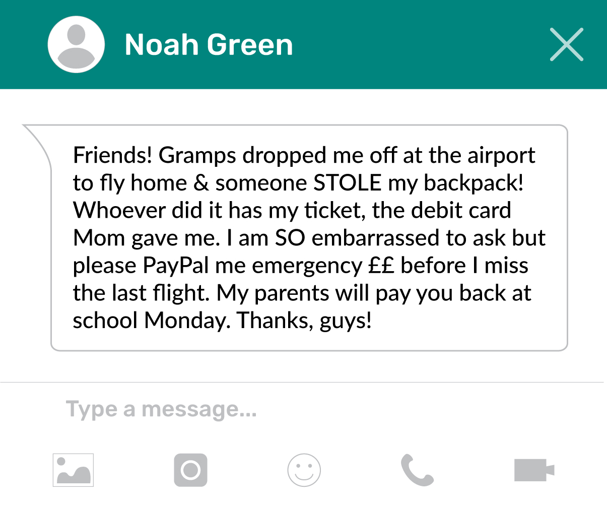 | Name the Phishing Clues
Website Pop-Up   | Name the Phishing Clues
Login Screen
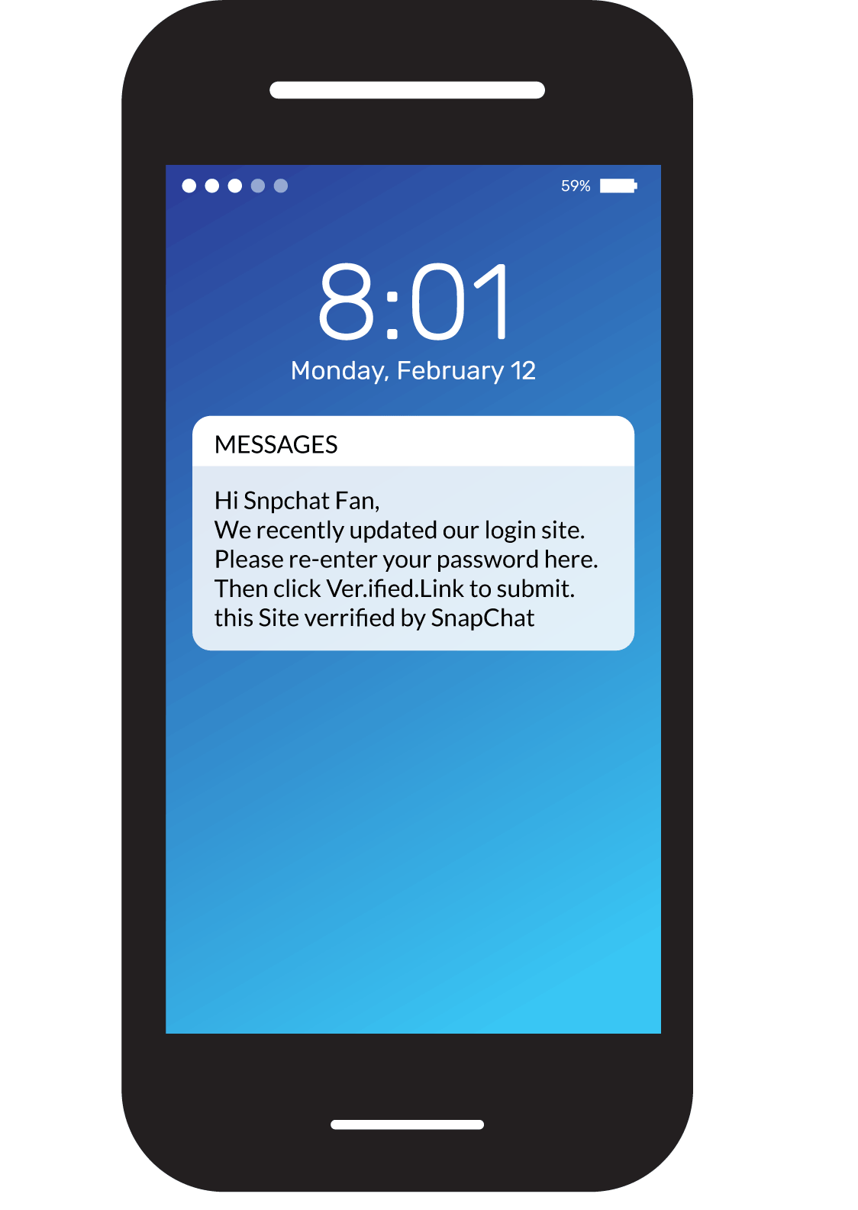

Text Message   | Name the Phishing Clues
Account Notification
